

Wear Your Choice….

**A Brief Report on**

**Code and Working of this Website**

Composed by:

* Muhammad Umar 23I-0782
* Muhammad Usman al Haq 23I-0585

Table of Contents

**1.Login Page 3**

**2.Signup Page 8**

**3.Home Page 12**

**4.Product Page** **19**

**5. Categories 29**

**6. Cart 36**

**7. Payment 42**

1. Login Page

**Webpage:**



**Code:**

* **HTML:**

<html>

    <head>

        <title>

            Welcome! Login

        </title>

        <link rel="stylesheet" type="text/css" href="First_page.css">

        <body>

            <div class ="Loginbox">

                <img src = "avatar.png" class = "avatar">

                <h1>Login Here</h1>

                <form>

                    <p>Username</p>

                    <input type="text" name="" placeholder="Enter Username">

                    <p>Password</p>

                    <input type="password" name="" placeholder="Enter Password">

                    <input type="submit" name="" value="Login"><br>

                    <a href="#">Forgot Password?</a><br>

                    <a href="signup.html">Don't have an Account?</a>

                </form>

            </div>

        </body>

    </head>

</html>

* **CSS:**
* body{
* margin: 0 ;
* padding: 0;
* background: url(Peaky_Wears_Login.png);
* background-size: 2750px 1050px;
* background-position: center;
* font-family: sans-serif;
* }
* .Loginbox{
* width: 600px ;
* height: 420px ;
* background: #000 ;
* opacity: 0.9 ;
* color:#fff ;
* top: 50% ;
* left: 50% ;
* position: absolute;
* transform: translate(-45% , -17%);
* box-sizing: border-box ;
* padding: 70px 30px;
* }
* .avatar{
* width: 100px;
* height: 100px;
* border-radius: 50%;
* position: absolute;
* top: -50px;
* left: calc(50% -50px);
* }
* h1{
* margin: 0;
* padding: 0 0 20px;
* text-align: center;
* font-size: 22px;
* }
* .Loginbox p{
* margin: 0;
* padding: 0;
* font-weight: bold;
* }
* .Loginbox input{
* width: 100%;
* margin-bottom: 20px;
* }
* .Loginbox input[type="text"] , input[type="password"]{
* border: none;
* border-bottom: 1px solid #fff;
* background : transparent ;
* outline: none;
* height: 40px;
* color: #fff;
* font-size: 16px;
* }
* .Loginbox input[type="submit"]{
* border: m=none;
* outline:none ;
* height: 40px;
* background: #fb2525;
* color: #fff;
* font-size: 18px;
* }
* .Loginbox input[type="submit"]:hover{
* cursor: pointer;
* background: #ffc107;
* color: #000;
* }
* .Loginbox a{
* text-decoration: none;
* font-size: 12px;
* line-height: 20px;
* color: darkgrey;
* }
* .Loginbox a:hover{
* color: blue;
* }

This HTML code represents a simple login page for a website. Here's an analysis:

**HTML Structure:**

* Title: The title is set as "Welcome! Login" for the page.
* External Stylesheet: Linked using <link> tag to a CSS file named "First_page.css".
* Body Section: Contains a login box with various elements.

**Login Box Structure:**

* Image: An avatar image represented by the <img> tag with the class "avatar".
* Header: An <h1> tag with the text "Login Here".
* Form: Includes a form element (<form>) containing:
* Username Field: An input field of type "text" for the username.
* Password Field: An input field of type "password" for the password.
* Login Button: A submit button to submit the login credentials.

**Links:**

* "Forgot Password?" link (#): Redirects to the same login page because it is asked to do front-end coding only.
* "Don't have an Account?" link ("signup.html"): Redirects to a sign-up page.

**CSS Styling:**

The CSS file "First_page.css" likely contains styles for the login box and its elements, **such as positioning, colors, font sizes, and other visual properties.**

**Body Styling:**

* Background: Utilizes an image named "Peaky_Wears_Login.png" as the background for the entire body.
* Background Properties: Specifies its size, position, and covers the entire body. Also, sets a sans-serif font for the entire body text.

**Login Box Styling:**

* Dimensions & Position: Defines the login box's width, height, and positions it at the center of the page using absolute positioning and transform properties.
* Background & Opacity: Sets a black background with 90% opacity to create a semi-transparent effect.
* Text Styling: Sets the text color to white and centers the text inside the box.

**Avatar Styling:**

* Dimensions & Position: Specifies the size and circular border-radius for the avatar image.
* Positioning: Places the avatar image at the top-center of the login box using absolute positioning.

**Input Fields and Button Styling:**

* Input Fields: Styles text input fields and password input fields with a bottom border, transparent background, and white text color. Removes default borders and outlines.
* Submit Button: Defines styles for the submit button, including background color, text color, and a hover effect.

**Link Styling:**

* Anchor Tags: Styles anchor tags for "Forgot Password?" and "Don't have an Account?" by defining text size, color, and hover effects.

1. Signup Page

**Webpage:**

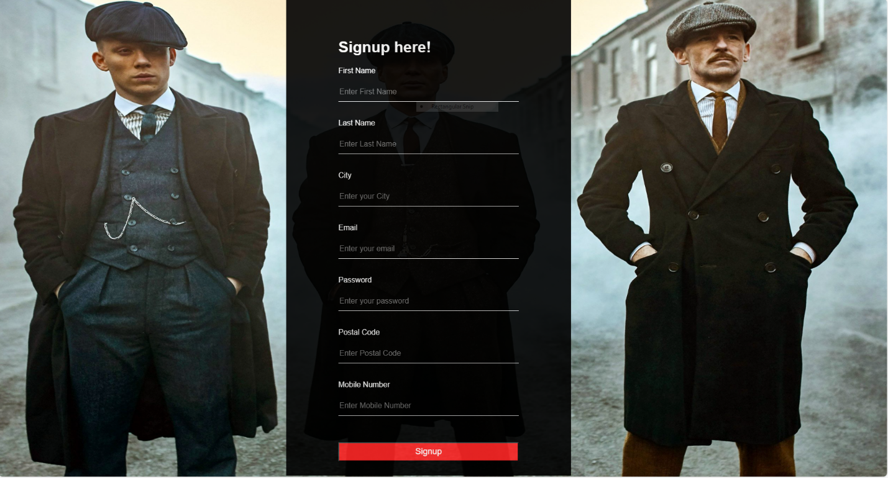

**Code:**

* **HTML:**

<html>

    <head>

        <title>

            Signup! Become our Family

        </title>

        <link rel="stylesheet" type="text/css" href="Signup_page.css">

        <body>

            <div class="Signup">

                <h1>

                    Signup here!

                </h1>

                <form>

                    <p>First Name</p>

                    <input type="text" name="" placeholder="Enter First Name">

                    <p>Last Name</p>

                    <input type="text" name="" placeholder="Enter Last Name">

                    <p>City</p>

                    <input type="text" name="" placeholder="Enter your City">

                    <p>Email</p>

                    <input type="email" name="" placeholder="Enter your email">

                    <p>Password</p>

                    <input type="password" name="" placeholder="Enter your password">

                    <p>Postal Code</p>

                    <input type="text" name="" placeholder="Enter Postal Code">

                    <p>Mobile Number</p>

                    <input type="text" name="" placeholder="Enter Mobile Number"><br><br><br>

                    <input type="submit" name="" value="Signup"><br>

                </form>

            </div>

        </body>

    </head>

</html>

* **CSS:**
* body{
* margin: 0 ;
* padding: 0;
* background: url(Peaky_Wears_signup.png);
* background-size: 1900px 1050px;
* background-position: center;
* font-family: sans-serif;
* }
* .Signup{
* width: 600px ;
* height: 1000px ;
* background: #000 ;
* opacity: 0.9 ;
* color:#fff ;
* top: 50% ;
* left: 50% ;
* position: absolute;
* transform: translate(-55% , -50%);
* box-sizing: border-box ;
* padding: 60px 110px;
* }
* .Signup input{
* width: 100%;
* margin-bottom: 20px;
* }
* .Signup input[type="submit"]{
* border: m=none;
* outline:none ;
* height: 40px;
* background: #fb2525;
* color: #fff;
* font-size: 18px;
* }
* .Signup input[type="submit"]:hover{
* cursor: pointer;
* background: #ffc107;
* color: #000;
* }
* .Signup input[type="text"] , input[type="password"] , input[type="email"]{
* border: none;
* border-bottom: 1px solid #fff;
* background : transparent ;
* outline: none;
* height: 40px;
* color: #fff;
* font-size: 16px;
* }

This HTML code represents a signup form for a website, allowing users to register by providing various personal details. Here's an analysis:

**HTML Structure:**

* Title: Title is set as "Signup! Become our Family" for the page.
* External Stylesheet: Linked using <link> tag to a CSS file named "Signup_page.css".
* Body Section: Contains a <div> element with a class "Signup" encompassing the signup form.

**Signup Form Structure:**

* Header: An <h1> tag with the text "Signup here!" representing the title of the signup section.
* Form: Includes a form element (<form>) containing several input fields:
* Personal Information: Fields for first name, last name, city, email, password, postal code, and mobile number.
* Submit Button: An input field of type "submit" to submit the signup details.

**Form Inputs:**

* Input Fields: Utilizes various input types (text, email, and password) along with placeholders for user guidance.
* br Tags: Utilizes <br> tags for line breaks, creating space between form elements.

**CSS Styling:**

**Body Styling:**

* Background: Uses an image named "Peaky_Wears_signup.png" as the background for the entire body.
* Background Properties: Specifies its size, position, and covers the entire body. Sets a sans-serif font for the entire body text.

**Signup Form Styling:**

* Dimensions & Position: Defines the signup form's width, height, and positions it at the center of the page using absolute positioning and transform properties.
* Background & Opacity: Sets a black background with 90% opacity to create a semi-transparent effect.
* Text Styling: Sets the text color to white and centers the text inside the form.

**Input Fields and Button Styling:**

* Input Fields: Styles text input fields, password fields, and email fields with a bottom border, transparent background, and white text color. Removes default borders and outlines.
* Submit Button: Defines styles for the submit button, including background color, text color, and a hover effect.

1. Home Page

**Webpage:**

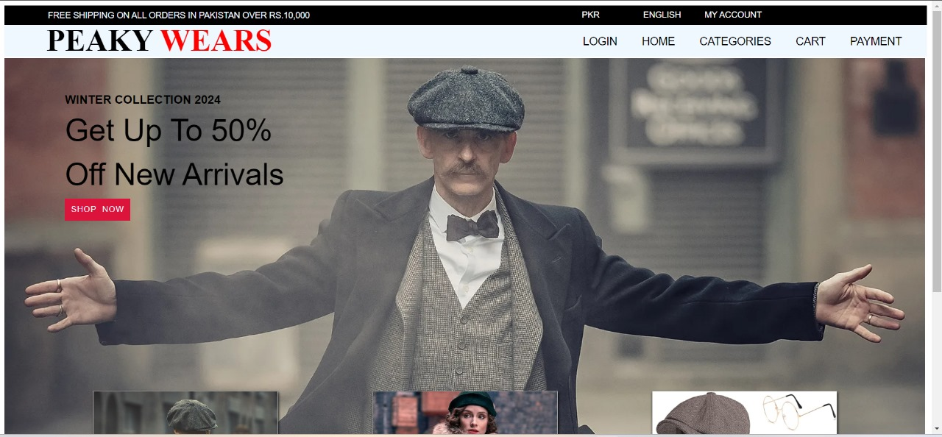

**Code:**

<html>

    <head>

        <style>

        .box1

        {

            border: 1px solid black;

            background-color: black;

            height:30px;

        }

        ul

        {

            float: left;

            color: red;

        }

        ul li

        {

            margin-top: -10px;

            float: left;

            position: relative;

            left: 300%;

            width: 100px;

            font-size: 14px;

            font-family: barlow condensed,sans-serif;

            list-style-type: none;

        }

        ul li a

        {

            text-decoration: none;

            color:white;

        }

        h5

        {

            margin-top: 1px;

            color:aliceblue;

            margin: 7px 12px;

            position: relative;

            left:-18%;

            font-family: barlow condensed,sans-serif;

            text-transform: uppercase;

            font-size: 14px;

            font-weight: normal;

        }

        .subbox

        {

            border: 1px solid transparent;

            background-color: aliceblue;

            height: 50px ;

        }

        ol

        {

            float: right;

        }

        ol li

        {

            float: left;

            margin-right: 40px;

            list-style-type: none;

            font-family: barlow condensed,sans-serif;

            font-size: 18px;

        }

        ol li a

        {

            text-decoration: none;

            color: black;

        }

        ol li a:hover

        {

            border-bottom: 4px solid red;

        }

        h3

        {

            color: red;

            position: absolute;

            left: 88.8%;

            top:4%;

            width:18px;

            height:-50px;

            border-radius: 100px;

            text-align: center;

            font-family: barlow condensed,sans-serif;

        }

        h2

        {

            position: absolute;

            left: 5%;

            text-transform: uppercase;

            font-family:'Times New Roman', Times, serif;

            font-weight: bolder;

            font-size: 50px;

            margin-top: -55px;

        }

        font

        {

            color: red;

        }

        .cover img

        {

            background-size: 530px;

            width: 1500px;

        }

        .text

        {

           position: absolute;

           top: 20%;

           left: 7%;

        }

        h1

        {

            font-size: 50px;

            font-family: barlow condensed,sans-serif;

            text-transform: capitalize;

            width: 400px;

            word-spacing: 0px;

            font-weight: normal;

            line-height: 72px;

        }

        h4

        {

            position:absolute;

            top:-8%;

            font-size: 120%;

            font-family: barlow condensed,sans-serif;

            font-weight: normal;

            text-transform: uppercase;

        }

        form input[type="submit"]

        {

            position: absolute;

            top: 86%;

            padding: 10px;

            text-transform: uppercase;

            background-color: crimson;

            border: 5px;

            color:aliceblue;

            font-family: barlow condensed,sans-serif;

            letter-spacing:1px;

        }

        form input[type="submit"]:hover

        {

            background-color: red;

        }

        .image22

        {

            position: absolute;

            left: 10%;

            top:90%;

            border: 1px solid darkgray;

            box-shadow: 1px 2px 4px;

        }

        h6

        {

            color: red;

            position: absolute;

            left:20%;

            top: 32%;

            border:1px solid whitesmoke;

            width:200px;

            font-size: 30px;

            font-family: barlow condensed,sans-serif;

            background-color:black;

            font-weight: normal;

            text-align: center;

        }

        .image22:hover

        {

            box-shadow: 1px 3px 9px ;

        }

        .image33

        {

            position: absolute;

            left: 40%;

            top:90%;

            border: 1px solid darkgray;

            box-shadow: 1px 2px 4px;

        }

        .image33:hover

        {

            box-shadow: 1px 3px 9px ;

        }

        h

        {

            color: red;

            position: absolute;

            left:20%;

            top: 50%;

            border:1px solid whitesmoke;

            width:200px;

            font-size: 30px;

            font-family: barlow condensed,sans-serif;

            background-color:black;

            font-weight: normal;

            text-align: center;

        }

        .image44

        {

            position: absolute;

            left: 70%;

            top:90%;

            border: 1px solid darkgray;

            box-shadow: 1px 2px 4px;

        }

        .image44:hover

        {

            box-shadow: 1px 3px 9px ;

        }

        t

        {

            color: red;

            position: absolute;

            left:10%;

            top: 50%;

            border:1px solid whitesmoke;

            width:250px;

            font-size: 30px;

            font-family: barlow condensed,sans-serif;

            background-color:black;

            font-weight: normal;

            text-align: center;

        }

        a

        {

            text-decoration: none;

            color: aliceblue;

        }

        </style>

    </head>

    <body>

        <div class ="box1">

            <ul>

                <li><a href="#">PKR</a></li>

                <li><a href="#">ENGLISH</a></li>

                <li><a href="#">MY ACCOUNT</a></li>

            </ul>

            <h5> Free shipping on all orders in Pakistan over Rs.10,000 </h5>

        </div>

        <div class="subbox">

            <ol>

                <li><a href="1st_page.html">LOGIN</a></li>

                <li><a href="mywebsite.html">HOME</a></li>

                <li><a href="Categories.html">CATEGORIES</a></li>

                <li><a href="cart.html">CART</a></li>

                <li><a href="payment.html">PAYMENT</a></li>

            </ol>

            </div>

                <h2><b>Peaky <font>Wears</font></b></h2>

            </div>

        </div>

        <div class="cover">

            <img src="homeimg.jpeg" width="2400" height="1300">

            <div class="text">

                <h1> Get Up to 50% off New Arrivals   </h1>

                <h4><b>Winter collection 2024</b></h4>

                <form action="" method="get">

                    <input type="submit" value="Shop  Now">

                </form>

            </div>

            </div>

            <div class="image22">

                <img src="homeimg3.jpeg" height="400" width="300">

                <h6><a href="products1.html">MEN'S</a></h6>

            </div>

            <div class="image33">

                <img src="homeimg2.jpeg" height="400" width="300">

                <h><a href="products2.html">WOMEN'S</a></h>

            </div>

            <div class="image44">

                <img src="homeimg1.jpeg" height="400" width="300">

                <t><a href="products3.html">ACCESSORIES</a></t>

            </div>

    </body>

</html>

**HTML Structure:**

* Header Section: Defines the style elements for different components like navigation bars, images, headings, etc.
* Body Section: Contains several divisions with classes box1, subbox, cover, image22, image33, and image44.
* Navigation Elements: Utilizes unordered lists and ordered lists for navigation menus.
* Text Styling: Utilizes various fonts, colors, sizes, and positions to style text elements (<h1>, <h2>, <h3>, <h4>, <h5>, <h6>, <t>, <font>) throughout the document.
* Form Element: it includes a form with a submit button styled for shopping purposes.
* Image Containers: Divs with classes containing images and links to different product categories.

**CSS Styling:**

* Positioning: We have utilized absolute and relative positioning for elements.
* Color Scheme: We have used black, red, and white colors for text, backgrounds, and borders.
* Box Shadows & Borders: a visual effect is given to the images using box shadows and borders.
* Hover Effects: Implements hover effects on links and images for interactivity.

1. Products Page

**Webpage:**

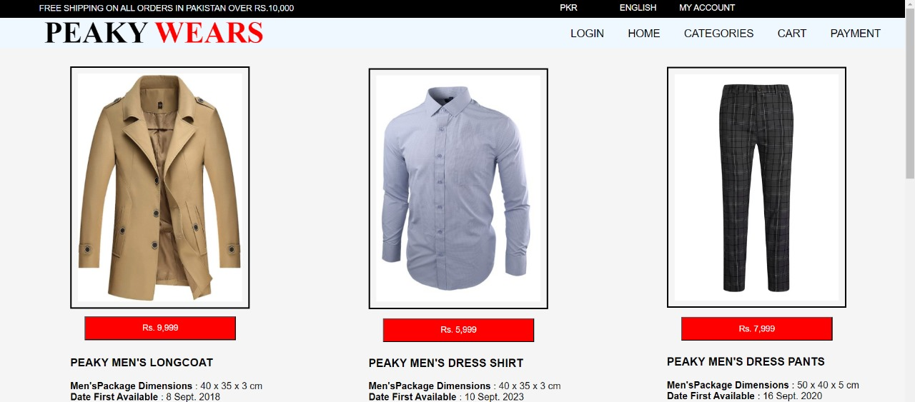

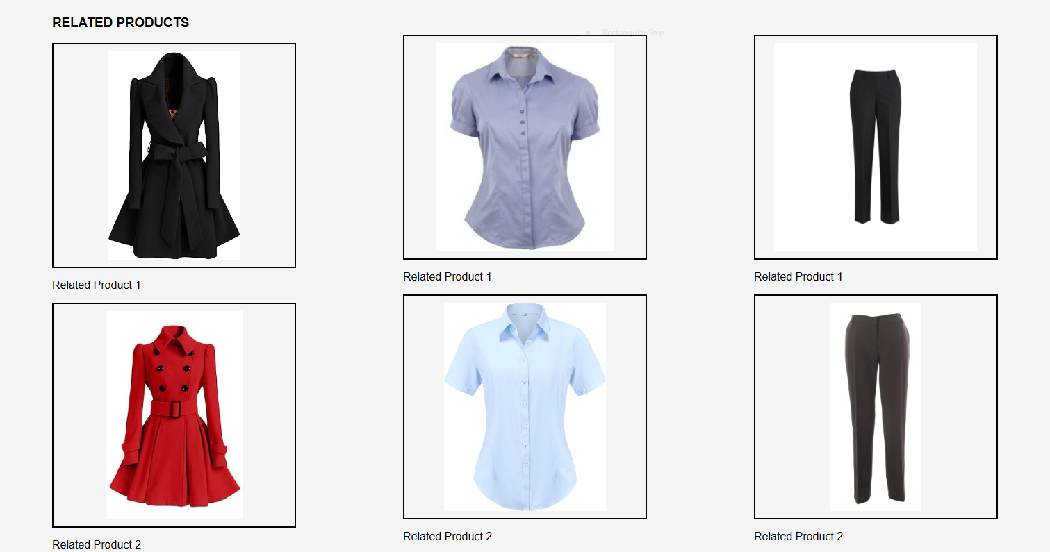

**Code:**

<html>

<head>

    <title>Men's Store</title>

    <style>

        body

        {

            font-family: Arial, sans-serif;

            margin: 0;

            padding: 0;

            background-color:  whitesmoke;

        }

        .container

        {

            width: 80%;

            margin-top: 10px;

            overflow: hidden;

            margin-left: 100px;

        }

        .container2

        {

            width: 80%;

            margin-top: -1490px;

            overflow: hidden;

            margin-left: 600px;

        }

        .container3

        {

            width: 80%;

            margin-top: -1485px;

            overflow: hidden;

            margin-left: 1100px;

        }

        .product-details

        {

            float: left;

            width: 60%;

            padding: 20px;

            box-sizing: border-box;

        }

        .product-details img

        {

            width: 40%;

            max-height: 500px;

            object-fit: cover;

            border: 2.5px solid black;

            padding: 10px;

        }

        .product-info

        {

            margin-top: 20px;

        }

        .add-to-cart-btn

        {

            background-color: red;

            color: white;

            padding: 10px 95px;

            text-align: center;

            text-decoration: none;

            display: inline-block;

            font-size: 14px;

            margin-top: 440px;

            margin-left: -685px;

        }

        .related-products

        {

            clear: both;

            margin-top: -25px;

            margin-left: 120px;

        }

        .related-products2

        {

            clear: both;

            margin-top: -25px;

            margin-left: 625px;

        }

        .related-products3

        {

            clear: both;

            margin-top: -25px;

            margin-left: 1130px;

        }

        .box1

        {

            border: 1px solid black;

            background-color: black;

            height:30px;

        }

        ul

        {

            float: left;

            color: red;

        }

        ul li

        {

            margin-top: -10px;

            float: left;

            position: relative;

            left: 300%;

            width: 100px;

            font-size: 14px;

            font-family: barlow condensed,sans-serif;

            list-style-type: none;

        }

        ul li a

        {

            text-decoration: none;

            color:white;

        }

        h5

        {

            margin-top: 1px;

            color:aliceblue;

            margin: 7px 12px;

            position: relative;

            left:-18%;

            font-family: barlow condensed,sans-serif;

            text-transform: uppercase;

            font-size: 14px;

            font-weight: normal;

        }

        .subbox

        {

            border: 1px solid transparent;

            background-color: aliceblue;

            height: 50px ;

        }

        ol

        {

            float: right;

        }

        ol li

        {

            float: left;

            margin-right: 40px;

            list-style-type: none;

            font-family: barlow condensed,sans-serif;

            font-size: 18px;

        }

        ol li a

        {

            text-decoration: none;

            color: black;

        }

        ol li a:hover

        {

            border-bottom: 4px solid red;

        }

        h2

        {

            position: absolute;

            left: 5%;

            text-transform: uppercase;

            font-family:'Times New Roman', Times, serif;

            font-weight: bolder;

            font-size: 50px;

            margin-top: -55px;

        }

        font

        {

            color: red;

        }

        p1

        {

            border: 1px solid darkgreen;

            padding: 10px;

            background-color: rgb(77, 255, 0);

            color: black;

            text-align: center;

            margin-left: 85px;

            cursor: pointer;

            margin-bottom: 20px;

            text-decoration: none;

        }

        h3

        {

            margin-top: 80px;

        }

        img

        {

            width: 22%;

            max-height: 600px;

            object-fit: cover;

            border: 2.5px solid black;

            padding: 10px;

        }

        a

        {

            text-decoration: none;

            color:aliceblue;

        }

    </style>

</head>

<body>

    <div class="box1">

        <ul>

            <li><a href="">PKR</a></li>

            <li><a href="">ENGLISH</a></li>

            <li><a href="">MY ACCOUNT</a></li>

        </ul>

        <h5> Free shipping on all orders in Pakistan over Rs.10,000 </h5>

    </div>

    <div class="subbox">

        <ol>

            <li><a href="1st_page.html">LOGIN</a></li>

            <li><a href="mywebsite.html">HOME</a></li>

            <li><a href="Categories.html">CATEGORIES</a></li>

            <li><a href="cart.html">CART</a></li>

            <li><a href="payment.html">PAYMENT</a></li>

        </ol>

    </div>

        <h2><b>Peaky <font>Wears</font></b></h2>

    <div class="container">

        <div class="product-details">

            <img src="overcoat.jpg">

            <div class="product-info">

                <h3>PEAKY MEN'S LONGCOAT</h3>

                <p> <b>Men'sPackage Dimensions</b> : 40 x 35 x 3 cm<br>

                    <b>Date First Available </b> : 8 Sept. 2018 <br>

                    <b>Manufacturer </b> : PEAKY WEARS <br>

                    <b>Manufacturer reference</b> : PEAKY-22 <br>

                    <b>ASIN</b> : B07H67G31W <br>

                    <b>Department</b> : Men's

                </p>

                <p1><a href="cart.html">Add to Cart</a></p1>

            </div>

        </div>

            <button class="add-to-cart-btn">Rs. 9,999</button>

    </div>

    <div class="container related-products">

        <h3>RELATED PRODUCTS</h3>

        <div class="product">

            <img src="overcoat3.jpg">

            <p>Related Product 1</p>

        </div>

        <div class="product">

            <img src="overcoat2.jpg">

            <p>Related Product 2</p>

        </div>

    </div>

    <div class="container2">

        <div class="product-details">

            <img src="shirt2.jpg" height="380px" >

            <div class="product-info">

                <h3>PEAKY MEN'S DRESS SHIRT</h3>

                <p> <b>Men'sPackage Dimensions</b> : 40 x 35 x 3 cm<br>

                    <b>Date First Available </b> : 10 Sept. 2023 <br>

                    <b>Manufacturer </b> : PEAKY WEARS <br>

                    <b>Manufacturer reference</b> : PEAKY-44 <br>

                    <b>ASIN</b> : B07H68G31W <br>

                    <b>Department</b> : Men's

                </p>

                <p1><a href="cart.html">Add to Cart</a></p1>

            </div>

        </div>

            <button class="add-to-cart-btn">Rs. 5,999</button>

    </div>

    <div class="container related-products2">

        <br>

        <br>

        <br>

        <br>

        <br>

        <br>

        <div class="product">

            <img src="shirt.webp" height="270px">

            <p>Related Product 1</p>

        </div>

        <div class="product">

            <img src="shirt3.webp">

            <p>Related Product 2</p>

        </div>

    </div>

    <div class="container3">

        <div class="product-details">

            <img src="pants.webp" height="380px">

            <div class="product-info">

                <h3>PEAKY MEN'S DRESS PANTS</h3>

                <p> <b>Men'sPackage Dimensions</b> : 50 x 40 x 5 cm<br>

                    <b>Date First Available </b> : 16 Sept. 2020 <br>

                    <b>Manufacturer </b> : PEAKY WEARS <br>

                    <b>Manufacturer reference</b> : PEAKY-32 <br>

                    <b>ASIN</b> : B07T67G31W <br>

                    <b>Department</b> : Men's

                </p>

                <p1><a href="cart.html">Add to Cart</a></p1>

            </div>

        </div>

            <button class="add-to-cart-btn">Rs. 7,999</button>

    </div>

    <div class="container related-products3">

        <br>

        <br>

        <br>

        <br>

        <br>

        <br>

        <div class="product">

            <img src="pants2.webp">

            <p>Related Product 1</p>

        </div>

        <div class="product">

            <img src="pants3.webp">

            <p>Related Product 2</p>

        </div>

    </div>

</body>

</html>

**HTML Structure:**

**Sub-header Section (subbox):**

* + A sub-header with links for login, home, categories, cart, and payment like all the other pages.

**Product Details (container):**

* + A container displaying details for a specific product (Peaky Men's Long Coat).
  + Includes an image, product information (dimensions, manufacturer details), and an "Add to Cart" button.
  + Women’s and Accessories are based on the same pages.

**Related Products Section (related-products):**

* + A section displaying related products with images and brief descriptions.

**Additional Product Details (container2, container3):**

* + Two additional containers providing details for more men's products (Peaky Men's Dress Shirt and Peaky Men's Dress Pants). Similarly Women’s and Accessories also have specific details related to them.
  + Each container includes an image, product information, and an "Add to Cart" button.

**Related Products Sections for Additional Products (related-products2, related-products3):**

* + Sections displaying related products for the additional men's dress shirt and dress pants.
  + Same is the case with women’s and accessories categories.

**CSS Styling:**

**Global Styling:**

* + Uses the Arial and sans-serif font family for the entire document.
  + Sets a background color of whitesmoke for the body.

**Container Styling (container, container2, container3):**

* + Each container is styled to have a width of 80%, margin, and overflow settings for layout control.

**Product Details Styling (product-details):**

* + Floats the product details to the left with a width of 60% and padding for spacing.
  + We applied a box-sizing property for consistent box model behavior.

**Image Styling (img):**

* + Images within the product details and related products are styled with a border, padding, and maximum height.

**Add to Cart Button Styling (add-to-cart-btn):**

* + The "Add to Cart" button is styled with a green background, white text, padding, and positioning for visual appeal.
  + Placed below the product details with a margin-top and margin-left for proper alignment.

**Navigation Styling:**

* + Consistent styling for navigation bars with borders, background colors, and font styles.
  + Navigation links have a white color with no underlines, and hover effects are applied to enhance the user’s experience.

1. Categories

**Webpage:**

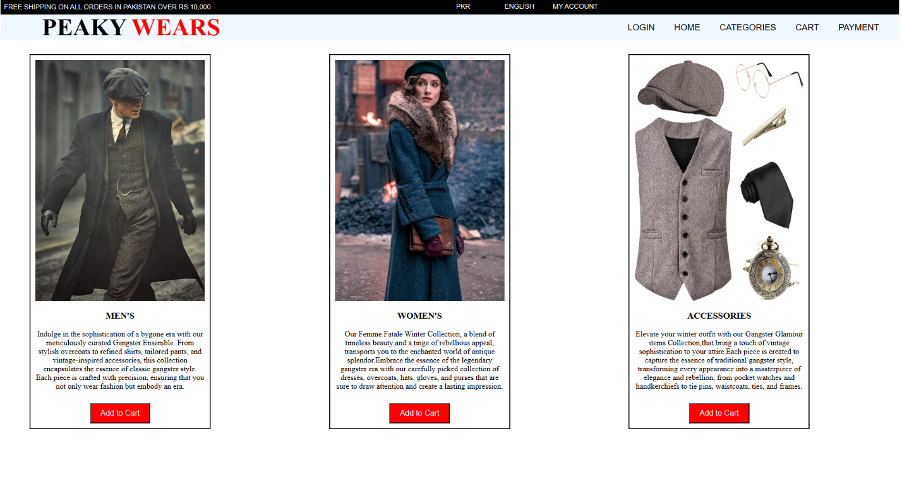

**Code:**

<html>

    <style>

        .box1

        {

            border: 1px solid black;

            background-color: black;

            height:30px;

        }

        ul

        {

            float: left;

            color: red;

        }

        ul li

        {

            margin-top: -10px;

            float: left;

            position: relative;

            left: 300%;

            width: 100px;

            font-size: 14px;

            font-family: barlow condensed,sans-serif;

            list-style-type: none;

        }

        ul li a

        {

            text-decoration: none;

            color:white;

        }

        h5

        {

            margin-top: 1px;

            color:aliceblue;

            margin: 7px 12px;

            position: relative;

            left:-18%;

            font-family: barlow condensed,sans-serif;

            text-transform: uppercase;

            font-size: 14px;

            font-weight: normal;

        }

        .subbox

        {

            border: 1px solid transparent;

            background-color: aliceblue;

            height: 50px ;

        }

        ol

        {

            float: right;

        }

        ol li

        {

            float: left;

            margin-right: 40px;

            list-style-type: none;

            font-family: barlow condensed,sans-serif;

            font-size: 18px;

        }

        ol li a

        {

            text-decoration: none;

            color: black;

        }

        ol li a:hover

        {

            border-bottom: 4px solid red;

        }

        h2

        {

            position: absolute;

            left: 5%;

            text-transform: uppercase;

            font-family:'Times New Roman', Times, serif;

            font-weight: bolder;

            font-size: 50px;

            margin-top: -55px;

        }

        font

        {

            color: red;

        }

        .product-section

        {

            display: flex;

            justify-content: flex-start;

            margin-top: 20px;

        }

        .product-column

        {

            flex: 1;

            text-align: center;

            margin-left: 50px;

        }

        .product

        {

            border: 2.5px solid black;

            padding: 10px;

            margin: 10px;

            width: 350px;

        }

        .product img

        {

            max-width: 100%;

            height: 500px;

            width: 100%;

        }

        .add-to-cart-btn

        {

            background-color: red;

            color: white;

            padding: 10px 20px;

            text-align: center;

            text-decoration: none;

            display: inline-block;

            font-size: 16px;

            margin-top: 10px;

            cursor: pointer;

        }

        a

        {

            text-decoration: none;

            color:aliceblue;

        }

    </style>

    <body>

        <div class="box1">

            <ul>

                <li><a href="">PKR</a></li>

                <li><a href="">ENGLISH</a></li>

                <li><a href="">MY ACCOUNT</a></li>

            </ul>

            <h5> Free shipping on all orders in Pakistan over Rs.10,000 </h5>

        </div>

        <div class="subbox">

            <ol>

                <li><a href="1st_page.html">LOGIN</a></li>

                <li><a href="mywebsite.html">HOME</a></li>

                <li><a href="Categories.html">CATEGORIES</a></li>

                <li><a href="cart.html">CART</a></li>

                <li><a href="payment.html">PAYMENT</a></li>

            </ol>

        </div>

        <h2><b>Peaky <font>Wears</font></b></h2>

        <div class="product-section">

            <div class="product-column">

                <div class="product">

                    <img src="fashion22.jpg">

                    <h3>MEN'S</h3>

                    <p>Indulge in the sophistication of a bygone era with our meticulously curated Gangster Ensemble.

                        From stylish overcoats to refined shirts, tailored pants, and vintage-inspired accessories,

                        this collection encapsulates the essence of classic gangster style.

                        Each piece is crafted with precision, ensuring that you not only wear fashion but embody an era.</p>

                    <button class="add-to-cart-btn"><a href="products1.html">Add to Cart</a></button>

                </div>

            </div>

            <div class="product-column">

                <div class="product">

                    <img src="img33.jpg">

                    <h3>WOMEN'S</h3>

                    <p>Our Femme Fatale Winter Collection, a blend of timeless beauty and a tinge of rebellious appeal,

                        transports you to the enchanted world of antique splendor.Embrace the essence of the legendary gangster

                        era with our carefully picked collection of dresses, overcoats, hats, gloves, and purses that are sure to

                        draw attention and create a lasting impression.</p>

                    <button class="add-to-cart-btn"><a href="products2.html">Add to Cart</a></button>

                </div>

            </div>

            <div class="product-column">

                <div class="product">

                    <img src="img44.jpg">

                    <h3>ACCESSORIES</h3>

                    <p>Elevate your winter outfit with our Gangster Glamour items Collection,that bring a touch of vintage

                     sophistication to your attire.Each piece is created to capture the essence of traditional gangster style,

                     transforming every appearance into a masterpiece of elegance and rebellion, from pocket watches and

                     handkerchiefs to tie pins, waistcoats, ties, and frames.</p>

                    <button class="add-to-cart-btn"><a href="products3.html">Add to Cart</a></button>

                </div>

            </div>

        </div>

    </body>

</html>

**HTML Structure:**

**Header Section:**

* + A header with a black background and white text, including links for currency, language, and account.
  + A message about free shipping in Pakistan for orders over Rs.10,000.

**Sub-header Section (subbox):**

* + A sub-header with links for login, home, categories, cart, and payment.
  + These are added in all other pages as well to enhance user interface.

**Product Section:**

* + A flex container with three product columns, each representing a clothing category (men's, women's, accessories).

**Product Columns (product-column):**

* + Each product column contains a product box with an image, category heading, description, and an "Add to Cart" button.
  + This button further takes you to the items of these categories where the user can select the items and Go to Cart for payment procedures.

**Product Boxes (product):**

* + Each product box has a border, padding, and margin for visual appeal.
  + An image representing the clothing category with a heading and  its description.

**CSS Styling:**

**Navigation Styling:**

* + The navigation bars (box1 and subbox) have a consistent style with black and white colors.
  + Links are styled with a red color.

**Product Section Styling (product-section):**

* + The product section is a flex container with a justified start alignment.
  + Product columns have a flex property of 1, which allows them to take up an equal amount of space.

**Product Column Styling (product-column):**

* + Product columns have a margin for spacing between them.

**Product Box Styling (product):**

* + Product boxes have a border, padding, and margin for a well-defined appearance.
  + Images within the product boxes have a maximum width of 100% and a fixed height.
  + Descriptions are provided for each clothing category.

**Add to Cart Button Styling (add-to-cart-btn):**

* + The "Add to Cart" button has a red background, white text, and padding for better visibility and making it consistent with the theme.
  + The button is styled as a link (anchor) for navigation to respective product pages.

**Global Styling:**

* + The 'barlow condensed' and 'sans-serif' font families are applied globally.
  + Red color is consistently used for emphasis.

1. Cart

**Webpage:**

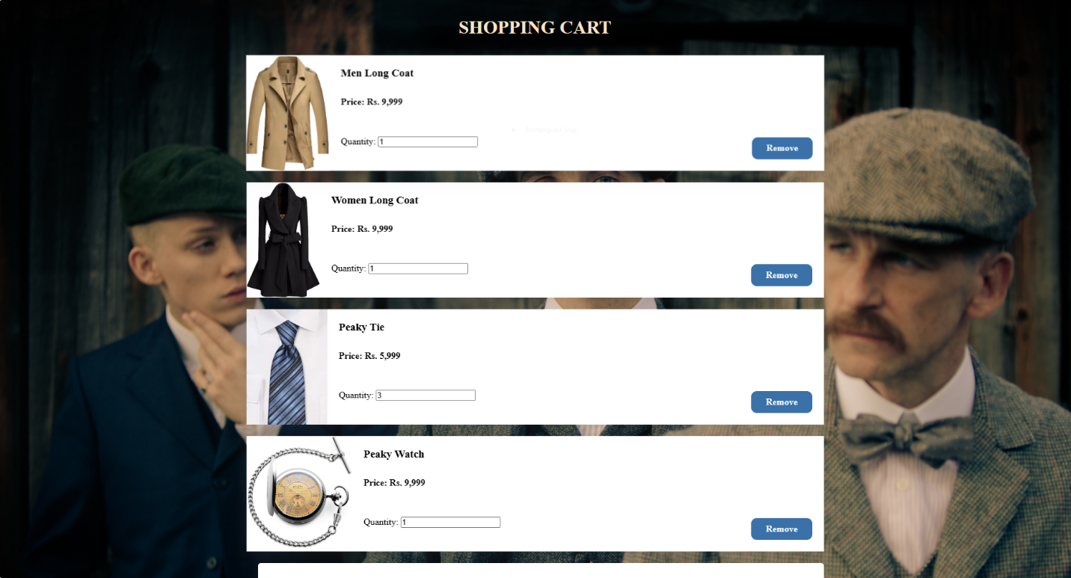

**Code:**

* **HTML**
* <html>
* <head>
* <title>
* Your Shopping Cart!
* </title>
* <link rel="stylesheet" type="text/css" href="cart_page.css">
* </head>
* <body>
* <div class="wrapper">
* <h1 style="color: bisque">Shopping Cart</h1>
* <div class="project">
* <div class="shop">
* <div class="box">
* <img src="img1.jpeg" alt="">
* <div class="content">
* <h3>Men Long Coat</h3>
* <h4>Price: Rs. 9,999</h4>
* <p class="unit">Quantity: <input value="1"></p>
* <p class="btn-area">
* <span class="btn2">Remove</span>
* </p>
* </div>
* </div>
* <div class="box">
* <img src="img2.jpeg" alt="">
* <div class="content">
* <h3>Women Long Coat</h3>
* <h4>Price: Rs. 9,999</h4>
* <p class="unit">Quantity: <input value="1"></p>
* <p class="btn-area">
* <span class="btn2">Remove</span>
* </p>
* </div>
* </div>
* <div class="box">
* <img src="img3.jpeg" alt="">
* <div class="content">
* <h3>Peaky Tie</h3>
* <h4>Price: Rs. 5,999</h4>
* <p class="unit">Quantity: <input value="3"></p>
* <p class="btn-area">
* <span class="btn2">Remove</span>
* </p>
* </div>
* </div>
* <div class="box">
* <img src="img4.jpeg" alt="">
* <div class="content">
* <h3>Peaky Watch</h3>
* <h4>Price: Rs. 9,999</h4>
* <p class="unit">Quantity: <input value="1"></p>
* <p class="btn-area">
* <span class="btn2">Remove</span>
* </p>
* </div>
* </div>
* <div class="right-bar">
* <p><span>Subtotal</span><span>Rs. 47,994</span></p>
* <hr>
* <p><span>Tax (5%)</span><span>Rs. 2,399.7</span></p>
* <hr>
* <p><span>Shipping Charges</span><span>Rs. 500</span></p>
* <hr>
* <p><span>Total</span><span>Rs. 50,893.7</span></p>
* <hr>
* <a href="#"></i>Proceed to Payment</a>
* </div>
* </div>
* </body>
* </html>
* **CSS:**

*{

    margin: 0;

    padding: 0;

    box-sizing: border-box;

}

body{

    font-family: montserrat;

    background: url(img5.png);

    background-size: cover;

}

.wrapper{

    max-width: 1000px;

    margin: 0 auto;

}

.wrapper h1{

    padding: 30px 0;

    text-align: center;

    text-transform: uppercase;

}

.project{

    display: flex;

}

.shop{

    flex: 75%;

}

.box{

    display:flex ;

    width: 100%;

    height: 200px;

    overflow: hidden;

    margin-bottom: 20px;

    background: #fff;

    transition: all .6s ease;

    box-shadow: rgba(100,100,111,0.2) 0 7px 29px 0;

}

.box:hover{

    transform: scale(1.02);

}

.content{

    padding: 20px;

    position: relative;

    width: 100%;

}

.content h3{

    margin-bottom: 30px;

}

.content h4{

    margin-bottom: 50px;

}

.btn-area{

    position: absolute;

    bottom: 20px;

    right: 20px;

    padding: 10px 25px;

    background-color: #3a71a9;

    color: #fff;

    cursor: pointer;

    border-radius: 10px;

    font-weight: 600;

}

.btn-area:hover{

    background-color: #76bfb6;

    color: #fff;

}

.btn-area i{

    margin-right: 5px;

}

.right-bar{

    flex: 5%;

    margin-left: 20px;

    padding: 30px;

    height: 400px;

    border-radius: 5px;

    background: #fff;

    box-shadow: rgba(100,100,111,0.2) 0 7px 29px 0;

}

.right-bar hr{

    margin-bottom: 20px;

}

.right-bar p{

    display: flex;

    justify-content: space-between;

    margin-bottom: 30px;

    font-size: 20px;

}

.right-bar a{

    background-color: #76bfb6;

    color: #fff;

    text-decoration: none;

    display: block;

    text-align: center;

    height: 40px;

    line-height: 40px;

    font-weight: 900;

}

.right-bar i{

    margin-right: 15px;

}

.right-bar a:hover{

    background-color: #3a71a9;

}

**HTML Structure:**

* Title: Set as "Your Shopping Cart!" for the page.
* External Stylesheet: Linked using <link> tag to a CSS file named "cart_page.css".
* Body Section: Contains various divisions (<div>) with classes like "wrapper," "project," "shop," "box," "content," and "right-bar" to structure the shopping cart items.

**Shopping Cart Items:**

* Item Boxes: Each <div> with class "box" represents a product in the shopping cart, containing:
* Image: <img> tag displaying an image of the product.
* Content: <div> with class "content" includes product details (name, price), quantity input, and a "Remove" button.

**Product Details:**

* Product Information: Each item displays details such as the product name, price, and a quantity input field.
* Remove Button: A "Remove" button represented as a <span> with the class "btn2" for removing items from the cart.

**Right Sidebar:**

* Summary: A sidebar displaying a summary of the cart:
* Subtotal: Total price before taxes and shipping.
* Tax: Calculated at 5% of the subtotal.
* Shipping Charges: A fixed shipping cost.
* Total: Total amount including subtotal, tax, and shipping charges.
* Proceed to Payment Link: An anchor tag directing to the payment page.

**CSS Styling:**

* Global Reset: The * selector resets margin, padding, and uses border-box sizing for all elements.
* Font: Applies the 'Montserrat' font to the entire document.
* Background: Sets a background image from 'img5.png' and sets it to cover the entire body.

**Layout and Structure:**

* Wrapper: Restricts the maximum width of the content to 1000px and centers it on the page.
* Heading Styles: Centers the <h1> text inside the wrapper, applying padding and uppercase transformation.
* Flexbox Structure:
  + Utilizes flexbox for a layout structure.
  + Divides content into two sections: "shop" and "right-bar" using display: flex.
  + .shop takes up 75% of the width while .right-bar takes up 25%.

**Product Display (.box and .content):**

* Box Styling: Sets up individual boxes for displaying products, each with a white background, a shadow, and a transition effect on hover.
* Content Styling: Manages the content inside the boxes, including product names (h3), prices (h4), and a "Remove" button area (btn-area).
* Hover Effect: Enlarges the box slightly on hover using the transform property.

**Right Sidebar (.right-bar):**

* Styling: Sets a white background with a shadow for the sidebar.
* Layout: Contains various elements (p, hr, a) to display cart summary details and a link for proceeding to payment.
* Link Styling: Formats the link with specific colors and hover effects.

1. Payment

**Webpage:**

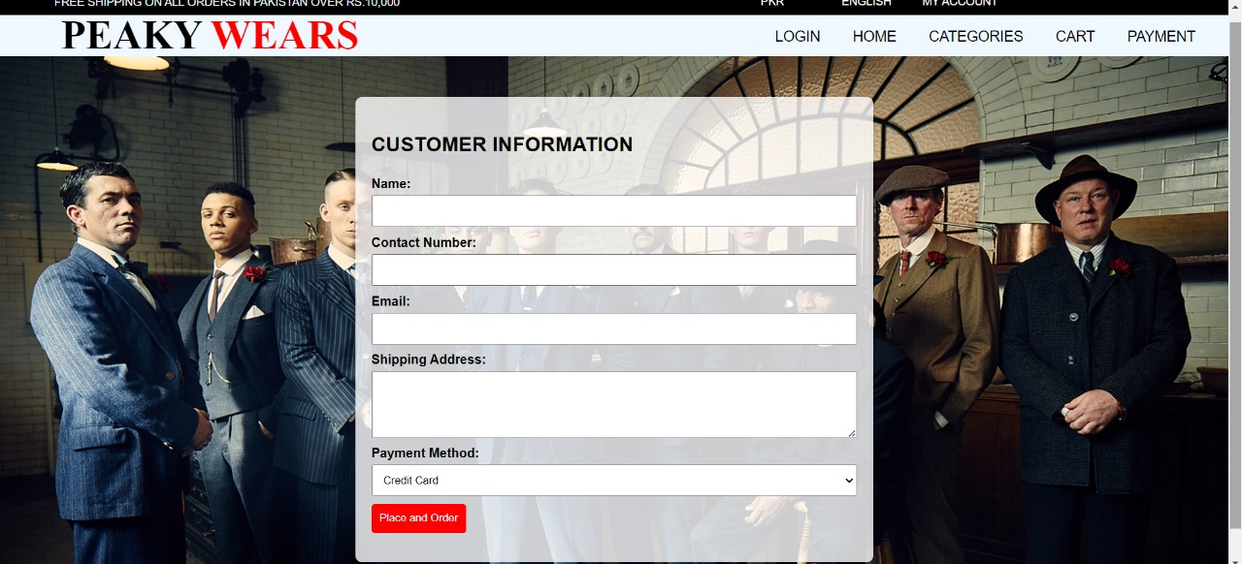

**Code:**

<html>

<head>

    <style>

        .box1

        {

            border: 1px solid black;

            background-color: black;

            height:30px;

        }

        ul

        {

            float: left;

            color: red;

        }

        ul li

        {

            margin-top: -10px;

            float: left;

            position: relative;

            left: 300%;

            width: 100px;

            font-size: 14px;

            font-family: barlow condensed,sans-serif;

            list-style-type: none;

        }

        ul li a

        {

            text-decoration: none;

            color:white;

        }

        h5

        {

            margin-top: 1px;

            color:aliceblue;

            margin: 7px 12px;

            position: relative;

            left:-18%;

            font-family: barlow condensed,sans-serif;

            text-transform: uppercase;

            font-size: 14px;

            font-weight: normal;

        }

        .subbox

        {

            border: 1px solid transparent;

            background-color: aliceblue;

            height: 50px ;

        }

        ol

        {

            float: right;

        }

        ol li

        {

            float: left;

            margin-right: 40px;

            list-style-type: none;

            font-family: barlow condensed,sans-serif;

            font-size: 18px;

        }

        ol li a

        {

            text-decoration: none;

            color: black;

        }

        ol li a:hover

        {

            border-bottom: 4px solid red;

        }

        h2

        {

            position: absolute;

            left: 5%;

            text-transform: uppercase;

            font-family:'Times New Roman', Times, serif;

            font-weight: bolder;

            font-size: 50px;

            margin-top: -55px;

        }

        font

        {

            color: red;

        }

        body

        {

            font-family: Arial, sans-serif;

            background-image: url('img5.jpg');

            background-size: cover;

            background-repeat: no-repeat;

            margin: 0;

            padding: 0;

        }

        .container

        {

            max-width: 600px;

            margin: 50px auto;

            background-color: rgba(255, 255, 255, 0.8);

            padding: 20px;

            border-radius: 8px;

            box-shadow: 0 0 10px rgba(0, 0, 0, 0.1);

        }

        form

        {

            margin-top: 20px;

        }

        label

        {

            display: block;

            font-weight: bold;

            margin-bottom: 5px;

        }

        input,

        textarea,

        select

        {

            width: 100%;

            padding: 10px;

            box-sizing: border-box;

            margin-bottom: 10px;

        }

        button

        {

            background-color: red;

            color: white;

            padding: 10px;

            border: none;

            border-radius: 4px;

            cursor: pointer;

        }

        button:hover

        {

            background-color: darkred;

        }

        h3

        {

            font-size: 25px;

        }

    </style>

</head>

<body>

    <div class ="box1">

        <ul>

            <li><a href="">PKR</a></li>

            <li><a href="">ENGLISH</a></li>

            <li><a href="">MY ACCOUNT</a></li>

        </ul>

        <h5> Free shipping on all orders in Pakistan over Rs.10,000 </h5>

    </div>

    <div class="subbox">

        <ol>

            <li><a href="1st_page.html">LOGIN</a></li>

            <li><a href="mywebsite.html">HOME</a></li>

            <li><a href="Categories.html">CATEGORIES</a></li>

            <li><a href="cart.html">CART</a></li>

            <li><a href="payment.html">PAYMENT</a></li>

        </ol>

        </div>

            <h2><b>Peaky <font>Wears</font></b></h2>

        </div>

    <div class="container">

        <h3>CUSTOMER INFORMATION</h3>

        <form action="mywebsite.html" method="get">

            <label for="name">Name:</label>

            <input type="text" id="name" name="name" required>

            <label for="contact">Contact Number:</label>

            <input type="tel" id="contact" name="contact" required>

            <label for="email">Email:</label>

            <input type="email" id="email" name="email" required>

            <label for="address">Shipping Address:</label>

            <textarea id="address" name="address" rows="4" required></textarea>

            <label for="payment">Payment Method:</label>

            <select id="payment" name="payment" required>

                <option value="credit">Credit Card</option>

                <option value="cash on Delivery">Cash On Delivery</option>

                <option value="bank">Bank Transfer</option>

            </select>

            <button type="submit">Place and Order</button>

        </form>

    </div>

</body>

</html>

**HTML Structure:**

* + The HTML document presents a webpage for a fashion store, specifically focusing on a customer information form.
  + The page has a navigation bar, a main heading, and a container for the customer information form.

**Navigation Bar :**

* + The navigation bar has a black background with white text, providing links for currency selection, language, and account access.
  + The "Free shipping" message is displayed prominently.

**Sub-navigation Bar (subbox):**

* + The sub-navigation bar contains links for various sections like login, home, categories, cart, and payment to enhance our website’s main theme.

**Clothing Name:**

* + The brand name "Peaky Wears" is styled with a red color, and the font is set to a combination of 'Times New Roman' and a fallback serif font.

**Background and Container:**

* + The background image (img5.jpg) is set to cover the entire viewport.
  + The container for the customer information form has a maximum width, a light background color with opacity, padding, and rounded corners.
  + A box shadow adds a subtle depth effect.

**Customer Information Form:**

* + The form includes fields for the customer's name, contact number, email, shipping address, and payment method.
  + Each input field has appropriate styling, and the form is enclosed within a container for better visual appeal.

**CSS Styling:**

* + The CSS file contains styling rules for various elements.
  + The navigation bar and sub-navigation bar have a consistent styling theme with the use of red and black colors as it is the theme of our website.
  + Fonts from the 'barlow condensed' and 'sans-serif' families are applied throughout the page.
  + Buttons and form elements have a consistent color scheme, with hover effects for better user feedback.
  + The font color 'red' is used for specific elements,  highlighting “Place and Order”.